19-9-2015

Mariano Orozco García

Procesamiento de señales biológicas, 3BM4

Tovar Corona Blanca

Signal Acquisition and Sampling Theorem

Practice 1

***Practice 1 - Signal Acquisition and Sampling Theorem***

***INTRODUCTION:***

***Signal acquisition:***

Also named Data Acquisition or DAQ, is the process of measuring an electrical or physical phenomenon such as voltage, current, temperature, pressure, or sound with a computer. A DAQ system consists of sensors, hardware, and a computer with programmable software. Compared to traditional measurement systems, PC-based DAQ systems exploit the processing power, productivity, display, and connectivity capabilities of computers. This data acquisition produces a discrete time signal by selecting the values of the continuous time signal at some sampling frequency. This sampling frequency give us a non-exact digital signal so we have to take in count some considerations in the data acquisition using the sampling theorem.

***Sampling Theorem:***

It only applies to band-limited signals, signals whose Fourier transforms are zero outside the (-B,B) region with a numerical B. It was proposed by Harry Nyquist and Claude Shannon. The theorem states that a sample-rate is sufficient for an accurate digital conversion if it is at least 2B samples per second. Furthermore, if a signal x is bandlimited to (-B,B), it is completely determined by its samples with sampling rate ωs = 2B. That is to say, x can be reconstructed exactly from its samples xs with sampling rate ωs = 2B. The angular frequency 2B is often called the angular Nyquist rate. This enables discrete time processing of continuous time signals, which has many powerful applications.

Then, the condition for a signal to be sampled is that the sample frequency must be at least twice the bigger frequency of the signal. This condition is recognized as the Nyquist criterion. If the Nyquist criterion is not satisfied, adjacent copies overlap, and it is not possible in general to discern an unambiguous X(f). Any frequency component above fs/2 is indistinguishable from a lower-frequency component, called an alias, associated with one of the copies. In such cases, the customary interpolation techniques produce the alias, rather than the original component. When the sample-rate is pre-determined by other considerations (such as an industry standard), x(t) is usually filtered to reduce its high frequencies to acceptable levels before it is sampled. We can see the aliasing effect in the Figure 1.

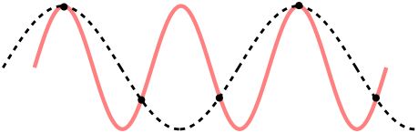

***Figure 1****. Aliasing Effect*

***GENERAL PROPUSE:***

To understand the importance of selecting a proper sampling frequency while measuring a signal, knowing the possible effects that the selected frequency can have in our data.

***PROCEDURE:***

The practice is divided in two main sections. In the first part of the practice we deal with different sampling frequencies. The sine wave is a 50Hz wave that will be generated with sampling frequencies in intervals of 100 Hz from 1000 Hz to 100 Hz and at 50 Hz.

We use the following code to generate the sine waves:

%% 1. Generate a sine wave at 50Hz using the following sampling frequencies:

VFs = [1000,900,800,700,600,500,400,300,200,100,50];

t = {};

x = {};

for i = 1:length(VFs);

Fs = VFs(i);

t{i} = 0:1/Fs:0.08;

x{i} = sin(2*pi*50*t{i});

if 1 == mod(i,4), figure, end

if 0 == mod(i,4)

subplot(4,1,4)

else

subplot(4,1,mod(i,4))

end

plot(t{i},x{i})

title(['50 Hz sine wave at fs = ',num2str(Fs)])

xlabel('Time (s)')

ylabel('A(v)')

end

In the second part of the practice we obtain a biological signal trough a microphone. The sound that we made while recording was the letter ‘A’ while trying to keep the same pitch. This generates a periodic signal that can be analyzed in the frequency domain. To obtain and save the recordings we use the following generic code:

tiempo = 2; % Sample signal for ~2 seconds

tic

Fs = X; % Change sampling rate

t1 = toc;

y = wavrecord(Fs*tiempo, Fs);

t2 = toc;

soundsc(y,Fs)

t = linspace(t1,t2,Fs*tiempo); % Time vector

figure('Name',['Fs: ', num2str(Fs),' Hz'])

plot(t,y*1000)

grid on

xlabel('Tiempo (s)');

xlim([t1,t2])

ylabel('Amplitud (mV)');

title(['Time: ',num2str(t2 - t1),' s.'])

pause(1);

save AX y t1 t2 t Fs tiempo

Were X in Fs and AX must be changed for the desired sampling frequency.

Finally to read the saved data, analyze and plot the recordings we used the next code:

%% 2 Plot a segment of your voice recordings for each sampling frequency:

Rec = {};

load A5000

Rec{1,1} = y;

Rec{1,2} = t;

Rec{1,3} = Fs;

load A11000

Rec{2,1} = y;

Rec{2,2} = t;

Rec{2,3} = Fs;

load A22000

Rec{3,1} = y;

Rec{3,2} = t;

Rec{3,3} = Fs;

load A44100

Rec{4,1} = y;

Rec{4,2} = t;

Rec{4,3} = Fs;

for i = 1:4

y = Rec{i,1};

t = Rec{i,2};

Fs = Rec{i,3};

y = y(0.7*Fs:1.7*Fs);

t = t(0.7*Fs:1.7*Fs);

Y = fft(y)/Fs;

Ie = floor(length(Y)/2);

f = (0:Ie-1)*((Fs/2)/(Ie-1));

% Graficar:

if mod(i,2) == 1, figure, end

j = i;

if i > 2; j = j - 2; end

subplot(2,2,j*2-1)

plot(t(0.85*Fs:0.86*Fs),y(0.85*Fs:0.86*Fs))

xlabel('Tiempo (s)');

xlim([t(0.85*Fs),t(0.86*Fs)])

ylabel('Amplitud (mV)');

title(['Voz a fs = ',num2str(Fs)])

subplot(2,2,j*2)

plot(f,abs(Y(1:Ie))/length(Y));

title(['Frecuency domain at Fs = ',num2str(Fs)])

xlabel('Frecuency (Hz)')

xlim([0,2000])

ylabel('|X(f)|')

end

***RESULTS:***

In the following figures (2-4) we can see the different 50 Hz sine waves that we generate.

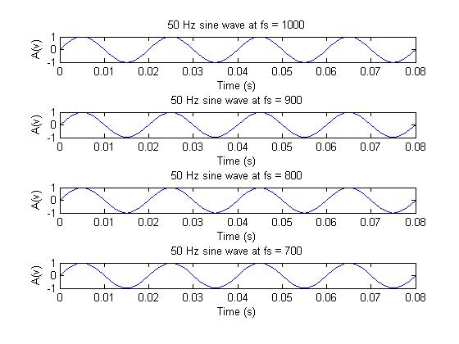

***Figure 2.*** *Sampled 50 Hz sine wave at 1000 Hz, 900 Hz, 800 Hz and 700 Hz*

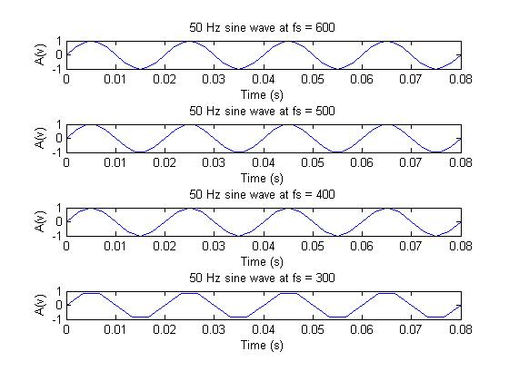

***Figure 3.*** *Sampled 50 Hz sine wave at 600 Hz, 500 Hz, 400 Hz and 300 Hz*

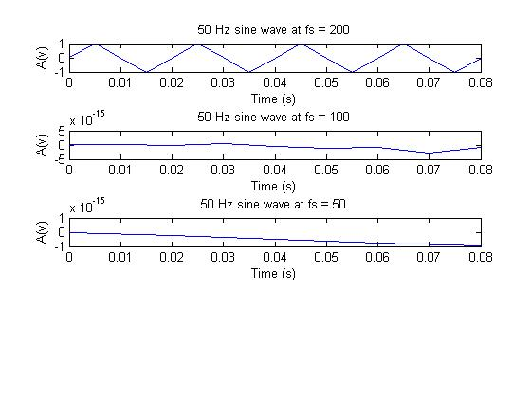

***Figure 4.*** *Sampled 50 Hz sine wave at 200 Hz, 100 Hz and 50 Hz*

We can see that the information that we have when the sampling frequency is low is deficient. Even when the sampling theorem suggest us to use at least the double of the frequency we can see that at 100 Hz is not possible to see that it comes from a sine wave. We start to see it at 200 Hz but with deficiencies. To avoid this we can suggest to use a 10 times bigger sampling frequency, i.e., 500 Hz.

In figure 5 and 6 we show the results of a segment of the signals with the spectrum in the frequency domain.

We can see that the signals with bigger sampling frequencies have more information in the time domain, they have more changes and are more precise. We can hear a weak difference while hearing the audios, when the sampling frequency is bigger the quality is bigger as well. This is more noticeable when you compare the 5000 Hz against the 44100 Hz. In the frequency domain we can see that the spectrum have more components with higher values and more peaks in general. Nevertheless, we notice that the principal ones at approximately 700 Hz, 350 Hz and around 1000 Hz are always present with some differences in amplitude.

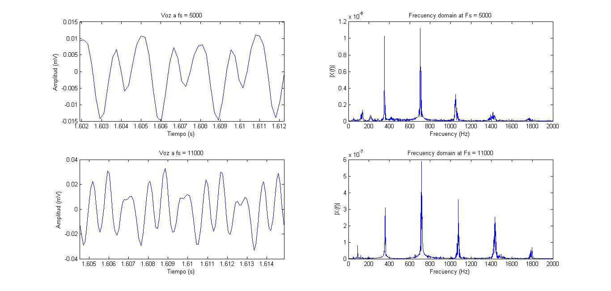

***Figure 5.*** *Voice recordings at 5000 Hz and at 11000 Hz*

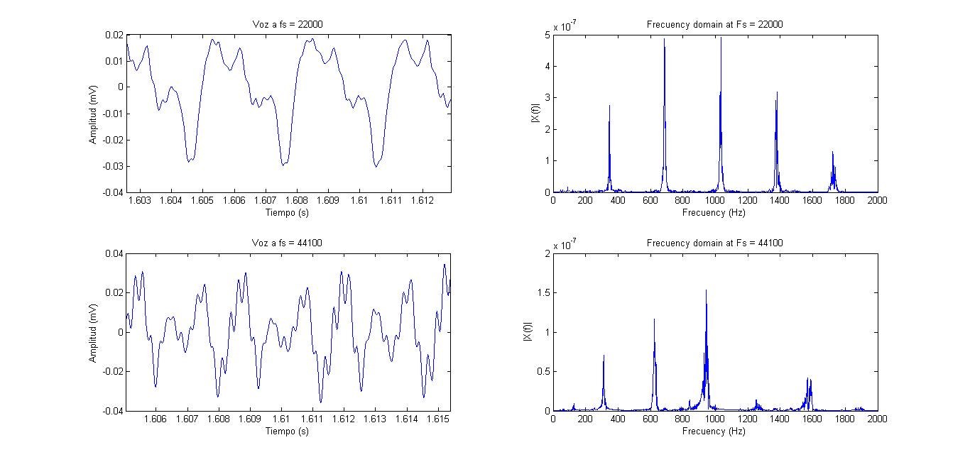

***Figure 6.*** *Voice recordings at 22000 Hz and at 44100 Hz*

***CONCLUSION:***

In this practice we were able to see the importance of choosing a good sampling frequency. We understand that the sampling frequency must be high enough to have good representative samples that can give us the information that we need and with which we can work.

The fundaments of the data acquisition were given by sampling a real signal. This knowledge can be extrapolated to any kind of signal. It is noticeable to remark that we have to adapt the data acquisition hardware to the specifications of the software. We have to configure both systems for the proper amplitudes and communication protocols.

As bionic engineers these kind of tools are the basis for any other application that we can design in the near future. This is a stage that we have to do to any signal that we want to process digitally so it is important to do it accurately not to lose important data.

***REFERENCES:***

1. National Instruments, *What Is Data Acquisition?*, <http://www.ni.com/data-acquisition/what-is/>, online [27/08/2014].
2. Rice University, Sampling Theorem, <http://cnx.org/contents/f65cf38c-c974-4a34-87b0-d4dc8863c79c@8>, online [27/08/2014].